**Professional Development Update**

*By Ha Nguyen, PMI Sydney Professional Development Director*

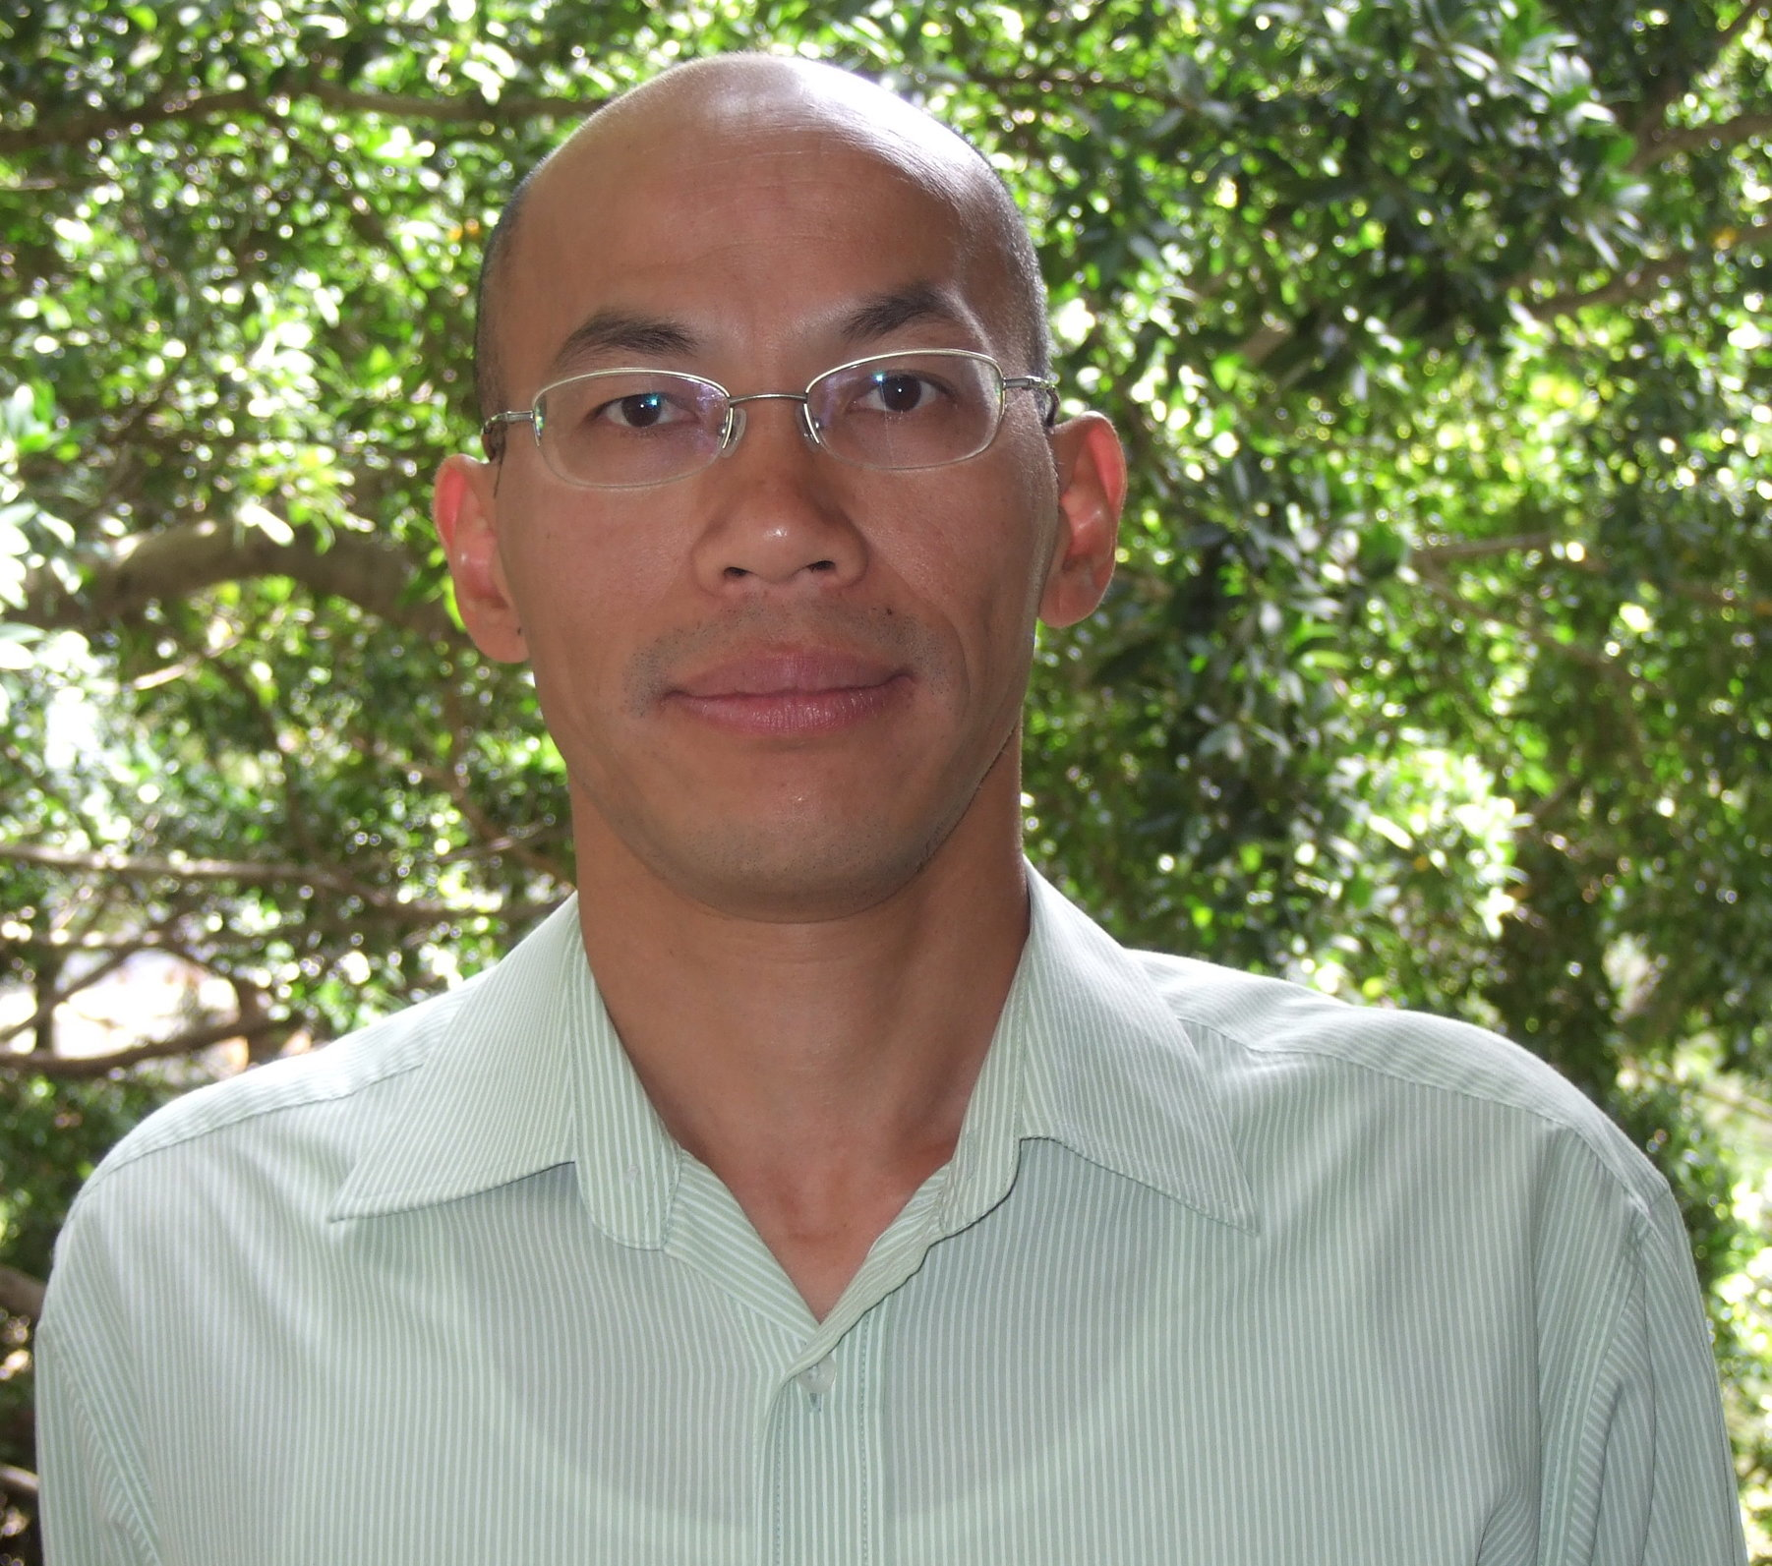

I am delighted to announce that Chris Deng has joined the team as a volunteer supporting Alastair Bor in Career Development. Chris specialises in Business Intelligence, Data Mining, Customer Intelligence, Business Analytics and Enterprise Systems. He has deep experience in Business Information Systems and Business Process Integration with ERP. He will be supporting Alastair in bringing new courses to fruition.

We will soon be kicking off the Lunch and Learn series sponsored by Wired Consulting. In 12 interactive and thought provoking 2 hour lunch and learn discussions you will be taken through 12 focus areas of Project Management that will explain techniques to increase your practice maturity. Topics covered include Effective Portfolio and Program Management through to Stakeholder Engagement and Benefits Management. Certificates of participation will be provided for all attendees and it is possible to claim PDUs for each workshop undertaken.

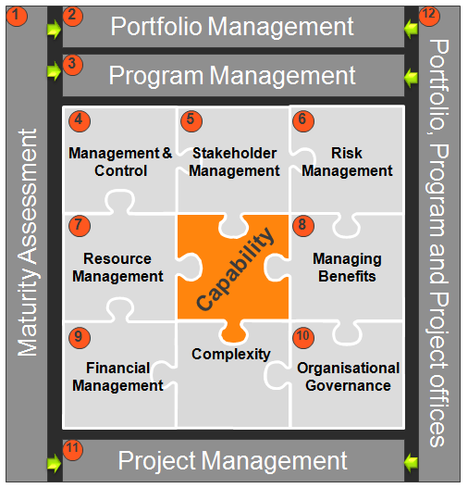

We have also completed our first Career Building Workshop which was over-subscribed and received great reviews. An additional course is scheduled for later in October. Stay tuned!